

SCU – Call for Content

Thank you for your interest in SCU 2015! Please fill out the information below and submit proposal to [emily.rodriguez@catapultsystems.com](mailto:emily.rodriguez@catapultsystems.com) . All presentations will be considered for one of three SCU tracks based on technology, solution, and audience level. Deadline for submissions is **November 16, 2015**.

Individual presentations should be approximately 60 minutes. Multiple sessions may be submitted.

**Content Committee**

All content selections will be made by the SCU content board consisting of Microsoft MVPs, Catapult Systems’ executives, and representatives from SCU Europe and SCU APAC. Those who submit a proposal will be notified November 20, 2015 indicating the status of their proposal.

**Content Requirements – Vendor Neutral**

The focus of your presentation must be on Microsoft solutions such as Azure, System Center, Windows Server 2012, Windows 10, IoT etc. Your session must present functional content in which the audience can implement and benefit from what is learned without necessarily purchasing any 3rd party particular product or professional service. Your session *may not name* any software vendor or tool, other than non-promotional free software tools.

\***Session Type**

?

\***Primary Product Covered**

PowerShell

\***Session Title**  
Simplifying Software Deployments in SCCM with PowerShell

\***Abstract**

All software packages are not created equal and it seems that no one software vendors’ packages their software up the same way even when picking the same packager! Whether you’re struggling with Windows Installer packages, InstallShield, NullSoft or simply just “installing” software by copying a few EXEs down to some machines what it takes to get it done varies greatly. We need a way to simply say Install-Software and it’s done.

We need a common framework to abstract away all of the mundane details so that we can just work with a single method to get software installed, uninstalled and detected in a clean, predictable fashion. We need a framework that automates all those file copies, registry value changes, certificate imports or whatever else we’re having to do to make our users happy to get software on our machines. And when everything is done, we also need a way to test to ensure all those configuration items are how we’d like.

In this session, we will. Using PowerShell, I will demonstrate the module that was created just for this purpose. I will demonstrate how to deploy various types of software using SCCM as a delivery mechanism while offloading all the client-side decisions regarding installing, uninstalling and finally detecting the configuration is how we’d like.

**Additional Product(s) Covered**

System Center Configuration Manager 2012 R2

**After viewing this session, what would the attendee know and do as a result of this training?**

The attendee will see a different way to handle what has traditionally big ad-hoc scripts per software deployment. They will learn how to use PowerShell to build a tool that they can use over and over again to eliminate the unnecessary redundancy that goes into client-side scripting once deployed with SCCM.

\***Proposed Demos**

Automating the installation and configuration of simple MSIs with PowerShell

Automating the installation and configuration of an InstallShield package with PowerShell

Automating software removals and cleanups

Using PowerShell to detect installed software and various other changes needed for deployments.

\***Level**

**300**

\***First Name**

Adam

\***Last Name**

Bertram

\***Email Address**

adbertram@gmail.com

\***Company**

Adam the Automator, LLC

**Company URL**

Adamtheautomator.com

**\*Job Title**

Independent Consultant

**\*Bio**

I am an independent consultant, technical writer, trainer and presenter. I specialize in consulting and evangelizing all things IT automation mainly focused around Windows PowerShell. I’m a Microsoft Windows PowerShell MVP, 2015 powershell.org PowerShell hero and have over 6 years experience managing SCCM 2007 – SCCM 2012R2. I author IT pro course content for Pluralsight, I’m a regular contributor to numerous print and online publications and present at various user groups and conferences.

**Have you presented on this topic before?**

**Yes**

**If yes, list the event name, date of events, and speaker evaluation scores (if applicable).**

TechMentor Redmond 2015

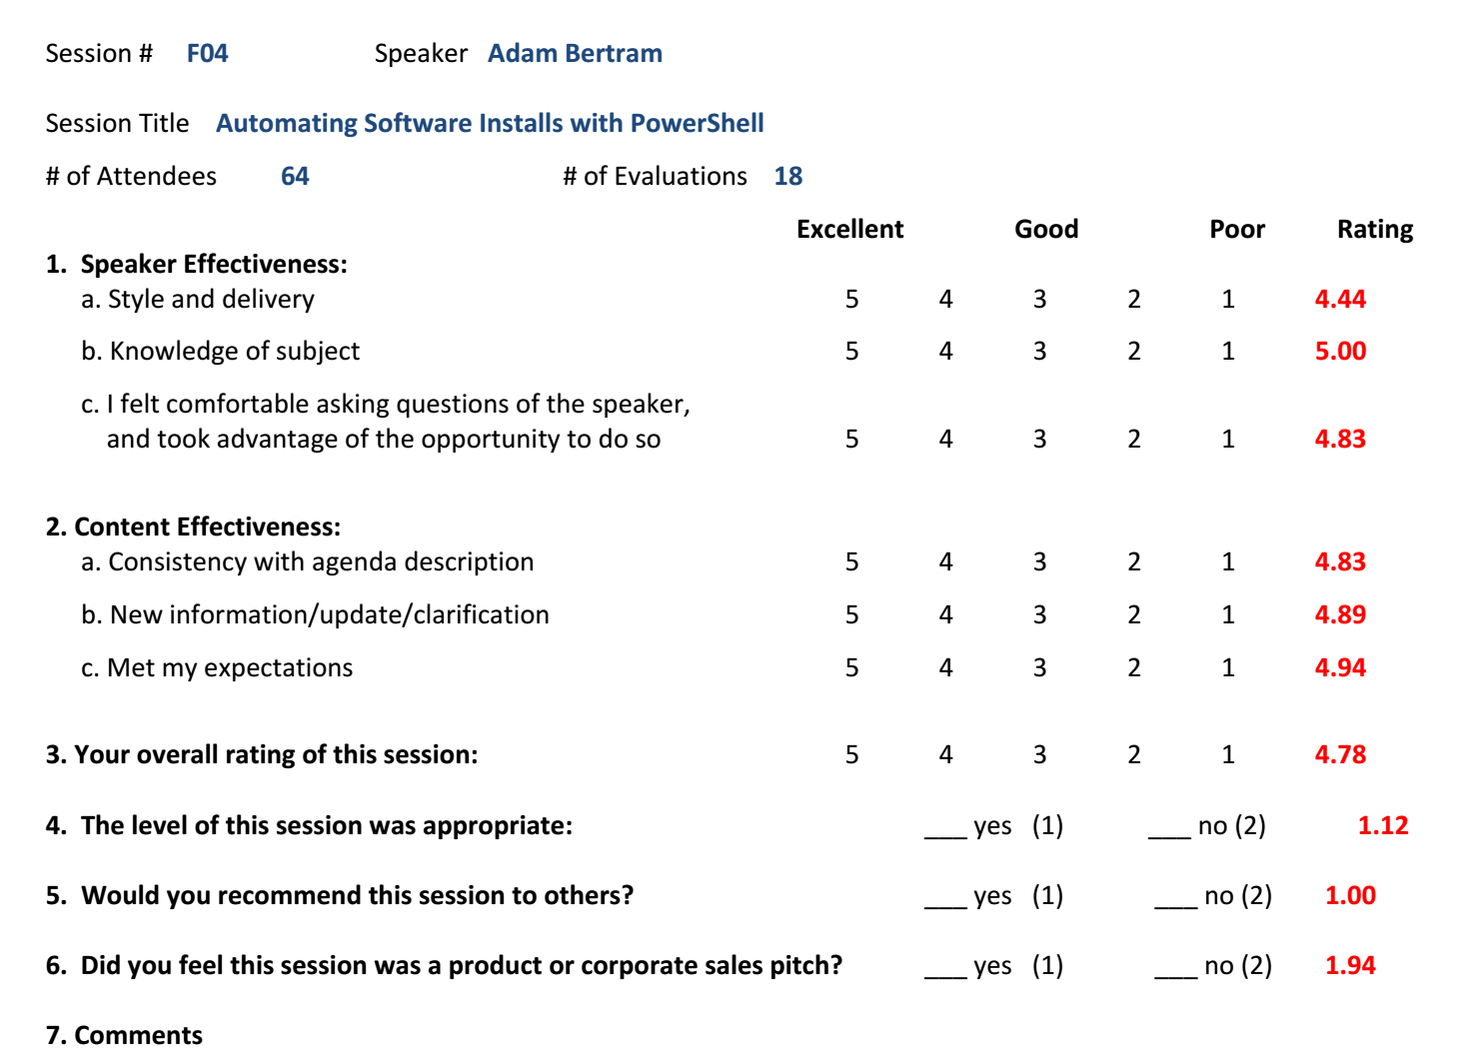

______X___ I agree to the Rules and Conditions for this Call for Sessions.